Git & IntelliJ Assignment

Explain the following questions in two simple sentences:

1. What is the use of the git add command?

Ans.) The git add command adds new or changed files in our working directory to the Git staging area. This means our changes are prepared and ready to be committed into the repository.

1. Write the command to create a branch “feature-group”.

Ans.) git branch feature-group

1. What is a pull request? Write the steps involved in creating a pull request.

Ans.) A pull request allows us to propose changes from our branch so they can be reviewed and merged into the main branch.  
**Steps:** Push our branch → Go to GitHub → Click “New pull request” → Select source and target branches → Click “Create pull request”.

1. How do you add collaborators?

Ans.) We can add collaborators by going to the repository settings on GitHub and selecting **Manage Access > Invite Collaborators**.  
After entering their GitHub username or email, they will receive an invitation to join our project.

1. What is the command used to commit our changes in github repo?

Ans.) git commit -m "Your commit message"

1. Create a github account and repository to save all your assignment tasks. Example repository name: rg-assignments

Ans.) https://github.com/Harshit-Raj-14/PayPal-RG-Assignment-Harshit-Raj

1. Create a branch called feature-java(you can use it later to push all your java related tasks to this branch)

Ans.) git branch feature-java

1. Install IntelliJ IDE. Create a simple java project displaying “Hello World!!”and share the screenshot.

Ans.) 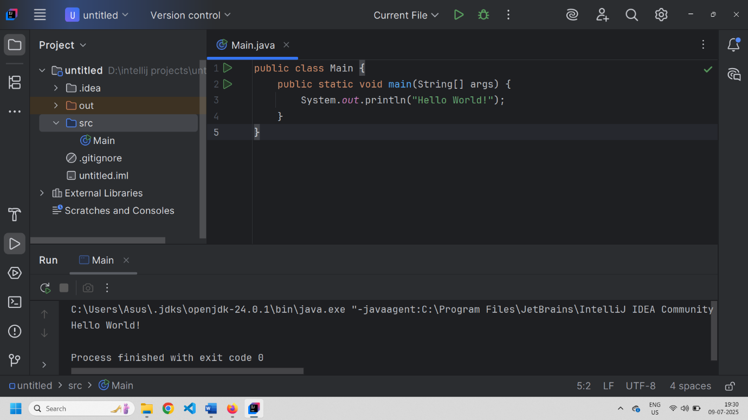

1. In IntelliJ IDE, explore the shortcut keys for the following:

Ans.)

* 1. To run the project - Shift + F10
  2. To select a line - Shift + End
  3. To comment/uncomment a line - Ctrl + /
  4. To delete a line - Ctrl + L